|  |  |  |
| --- | --- | --- |
| Student House BV | | |
|  |  |  |
| **Project Plan** | | |

Contents

Introduction - Client 1

Current situation 2

Our team 2

Problem definition 2

Project goals achieved 3

Our solution 4

Process 7

Communication methods 8

Conclusions 8

Advice and improvements 9

# Introduction - Client

* Student Housing BV is a company that offers accommodation to students who study in the Netherlands. They have multiple buildings with 7 rooms each displayed on 2 floors and some shared facilities such as a kitchen, 2 bathrooms, a living room and a storage space. They can be contacted through both the telephone and email, but also at the restaurant during the working hours.
* They started receiving complaints from clients about people not cleaning the shared facilities, disposing of the garbage on time or paying for the shared supplies. Moreover, unannounced parties and gatherings kept happening as well as random guests staying for entire weeks.

# Current situation

* Since they started receiving more and more complaints about serious problems, Student Housing BV believes that there are even more minor issues that are not being communicated by the students. As an extra service, they want to deliver an application the clients could use to make agreements between them, file complaints or see the house rules without directly contacting the company. The application should have different levels of security for different users and will be checked regularly by some members of the staff.

# OUR Team

* Ciupercă Diana – Team leader
* Draganova Denitsa – Developer
* Garkov Aleksandar– Developer
* Garboutchev Antonio – Developer

# PROBLEM definition

* **Cleaning the common spaces**
* Shared facilities (living room, kitchen, bathrooms etc.) are not being cleaned on time, or are cleaned by the same people over and over again. **Why?**
* Because people are forgetting or are disinterested. **Why?**
* Because they don’t have a schedule or some rules to follow.
* **Payment for shared supplies**
* People are buying supplies for the whole building such as dish soap, toilet paper, cleaning products etc. and they don’t receive their money back from their housemates, even though the products are for general use. **Why?**
* Because people often forget what was bought, who bought the products or they are not even aware that supplies have been bought at all. **Why?**
* Because it is difficult to inform an entire building and keep track of every purchase that has been made.
* **Garbage disposal**
* Garbage is not disposed of on time (the days on which the garbage truck comes). **Why?**
* People don’t know the schedule of the garbage truck. **Why?**
* They are not given all the information or don’t know what to ask.
* **Unannounced parties**
* People are throwing parties and have people over without informing the other housemates or getting their approval. **Why?**
* They don’t care about what their housemates think or they don’t know about their boundaries. **Why?**
* They don’t talk to them to each other in order to arrange agreements.
* **Lack of proper communication**
* People don’t properly discuss between them and often problems appear because of that. **Why?**
* They are not comfortable with each other and don’t spend enough time together in order to get to know each other better. **Why?**
* They have different friend groups and can’t find time to sit together due to their different schedules. **Why?**
* They don’t have the means necessary to easily organize meetings.

# Project goal ACHIEVED

* Assign tasks for each member of the house
* Give possibility to send public or private complaints
* Create a space for making proposals
* Possibility of creating agreements between tenants
* Offer information and present house rules
* Offer contact info for each tenant as well as the supervisor(s) of the building
* Create a friendly and organized environment
* Improve quality of living

# Our Solution

We came up with a software solution that will solve most, if not all, of the problems that were mentioned before. It has the features necessary for the students to better communicate and organize their tasks in the house. Here are some of the best features that the application offers:

* **Login/Register Page**

The first window that appears is a login/register page, where each user (both a tenant and a supervisor) can create an account with their provided email from the company and then log in with their email and the password they created. The information is safely and securely stored in an encrypted file, so here is no room for information leaks.

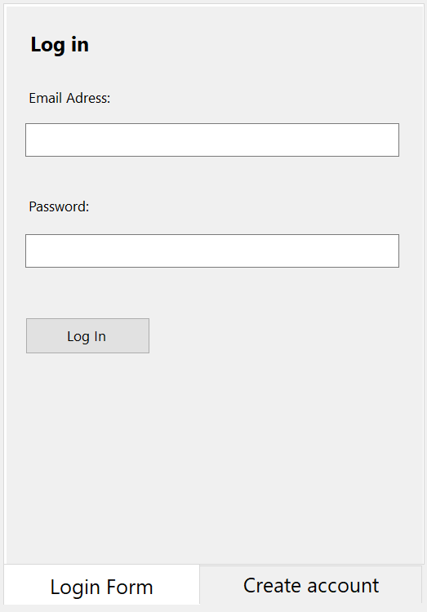 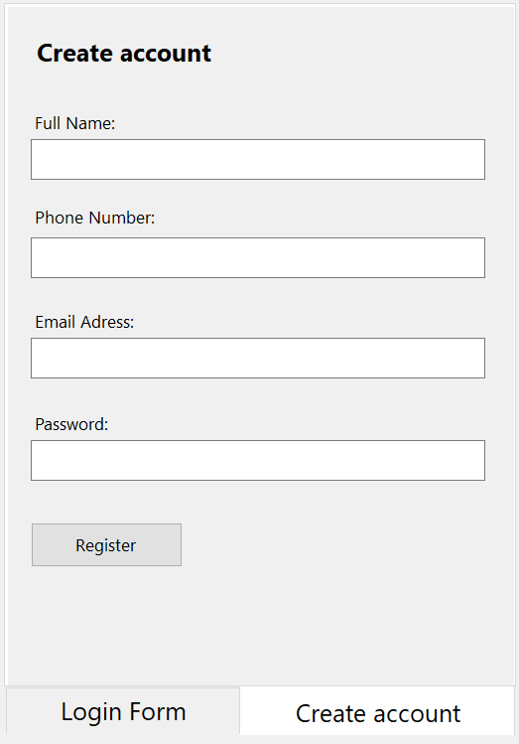

* **Student Interface**
* ***House Rules & Contact Info***

Displays the rules that the tenants need to follow, which are set by the supervisors from the company. It also display the contact info for all the current tenants and supervisors in order to be easier and faster to contact them if there is any urgent matter.

* ***Event Schedule***

Displays the events that are going to happen (rent is due, investors are coming over, the cleaning team is scheduled to come etc.) as well as the cleaning tasks for that week. Each tenant marks when they cleaned their assigned space and report to the supervisors if someone didn’t do their job on time.

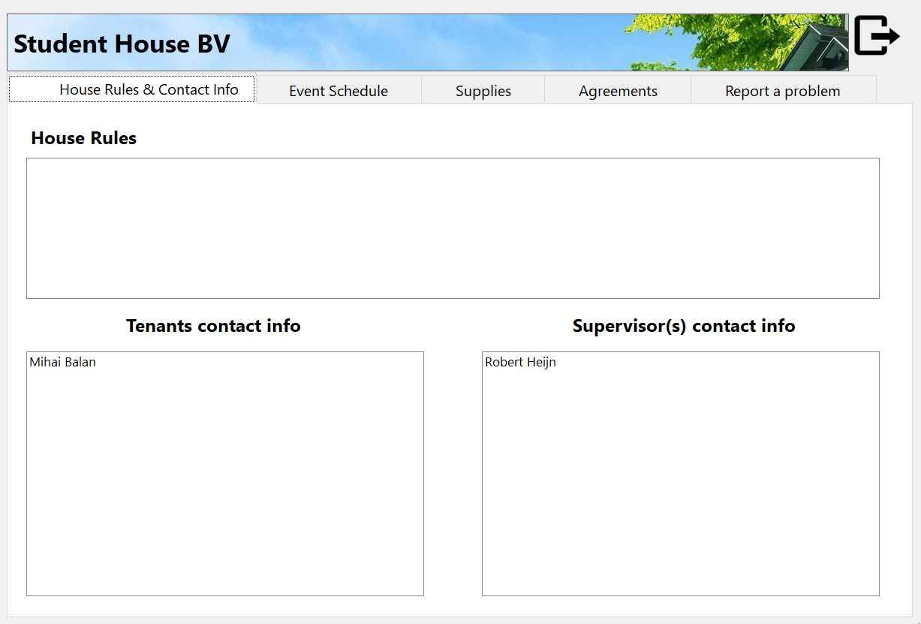 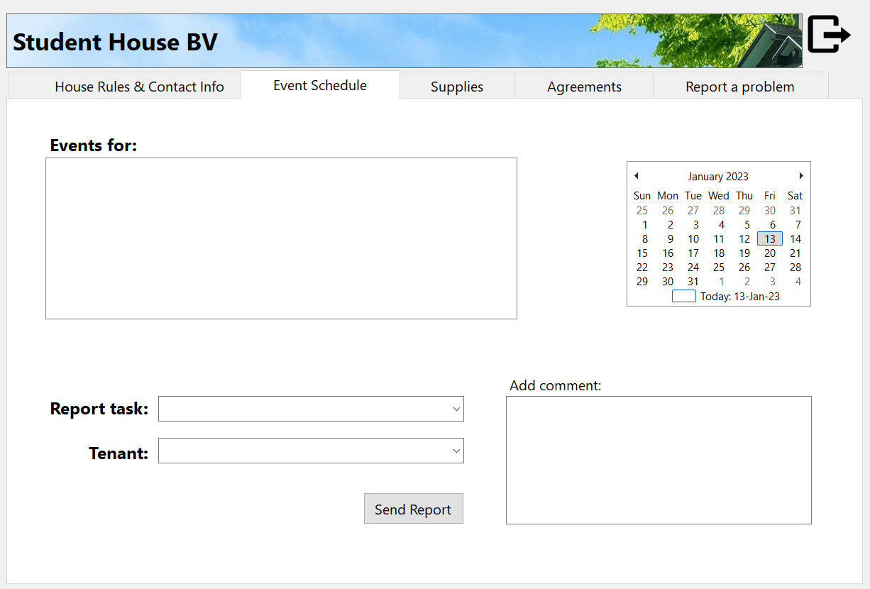

* ***Supplies***

Tenants can check what products they bought for the house and the total price and the application calculates the amount each tenant has to pay based on the total number of tenants. Anyone can see who paid and who didn’t and when a payment is completed, it gets deleted.

* ***Agreements***

Tenants can propose events or announce their housemates if they want to have guests

And the others can either agree or disagree. If a proposal reaches over 70% of votes, it gets approved and sent to the event page.

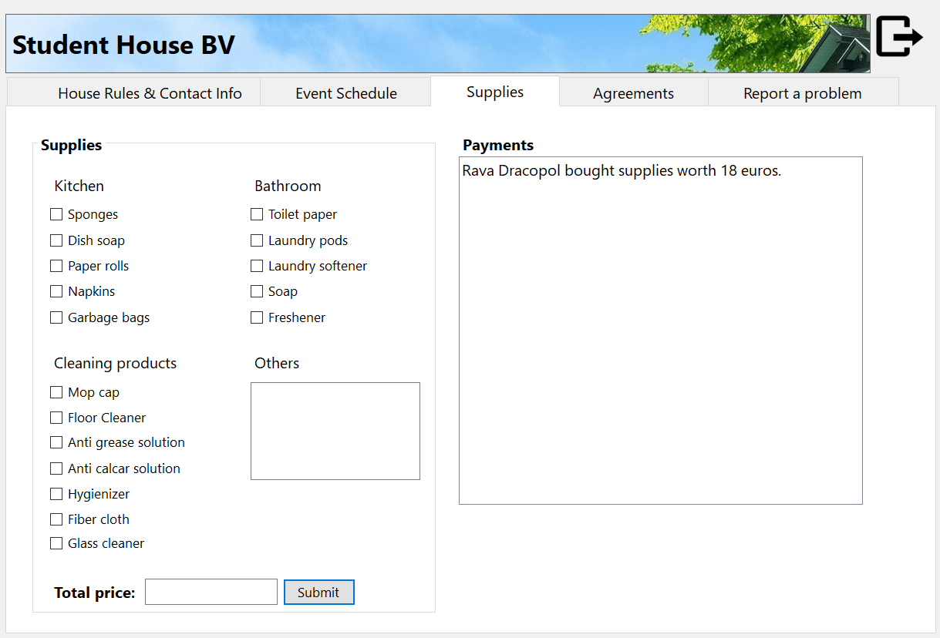 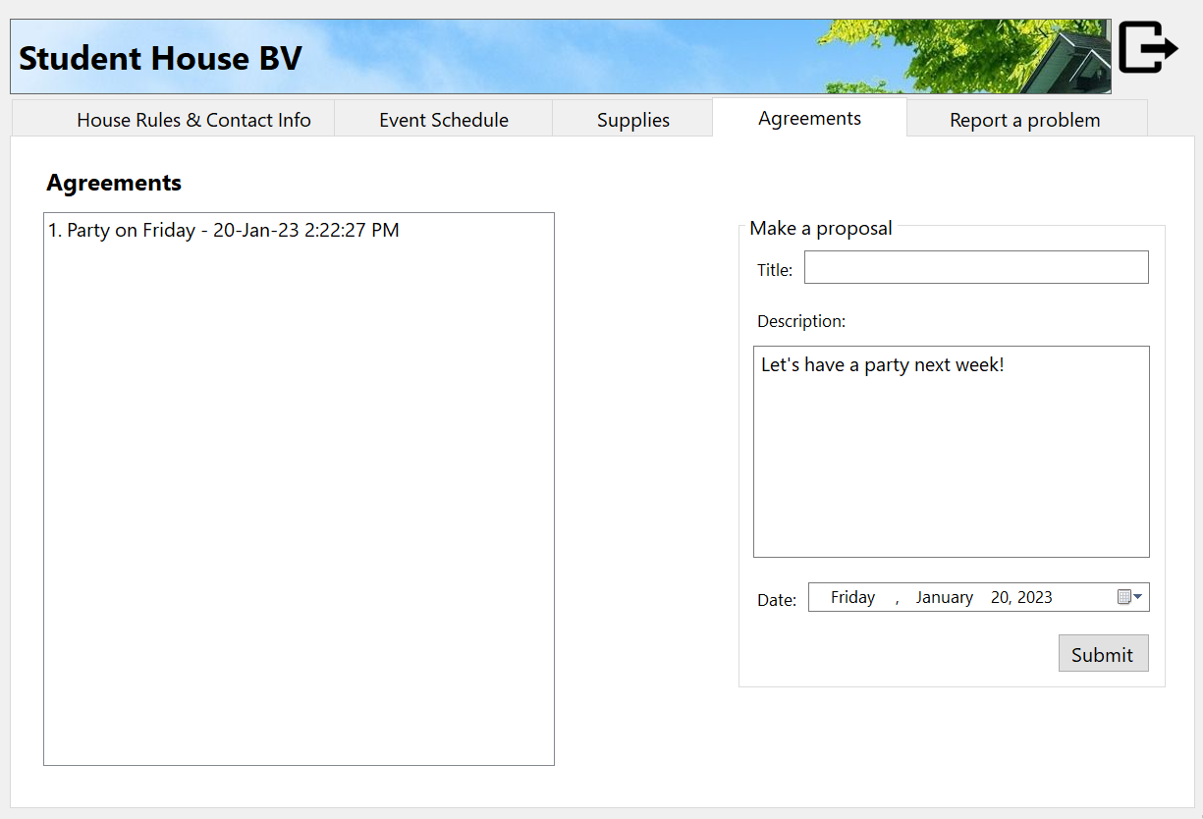

* ***Report a problem***

Tenants can send reports to the company to inform them of any damage or wrongdoing of another tenant. They can also see the warnings they received from the company for their behaviour during the stay.

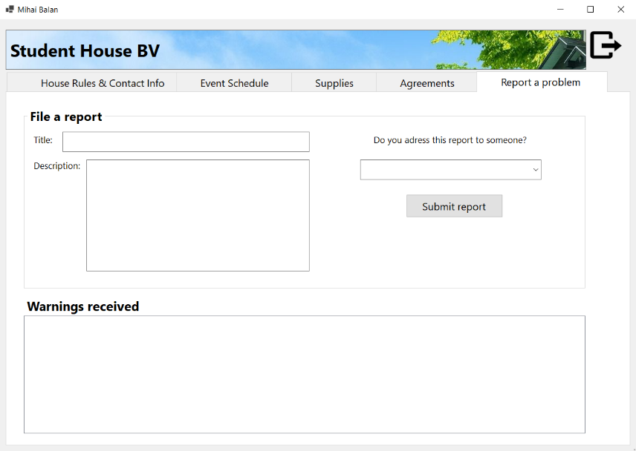

* **Supervisor Interface**
* ***House Rules***

Supervisors can set, add or edit the rules of the house that the tenants must follow.

* ***Contact Info***

Supervisors can add or edit the name and credentials of a student, as well as assign him to a specific room from the house. They can edit their own contact information, too.

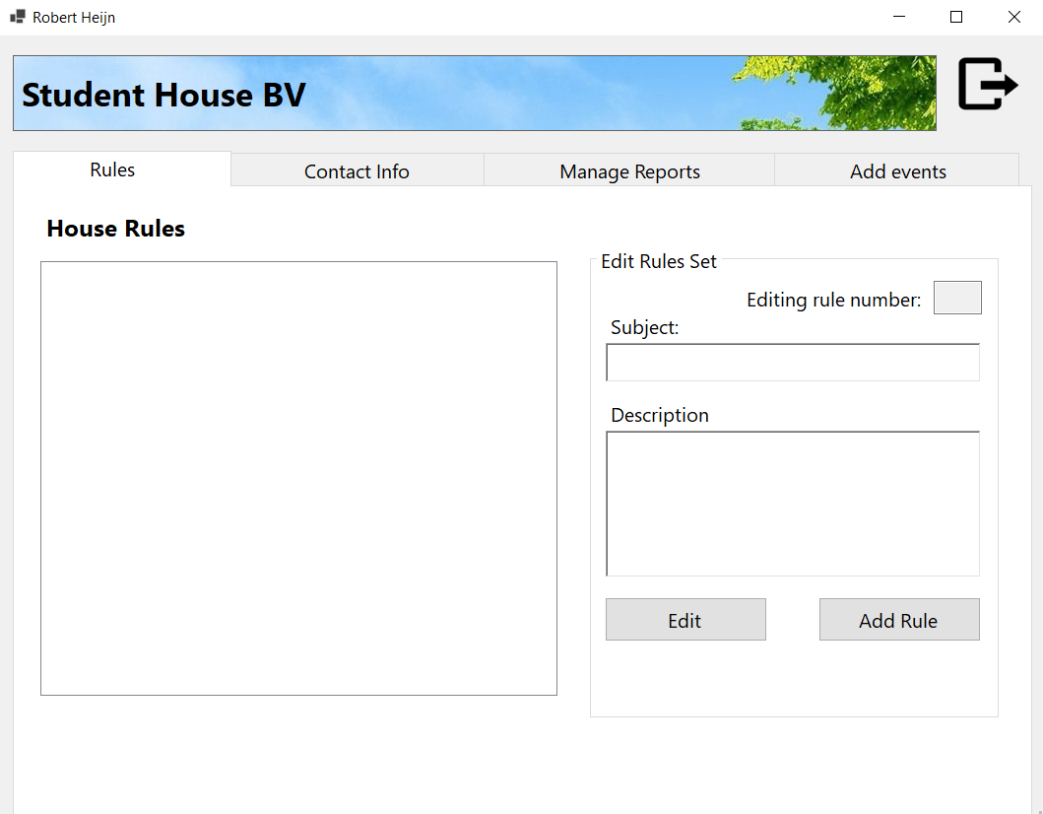 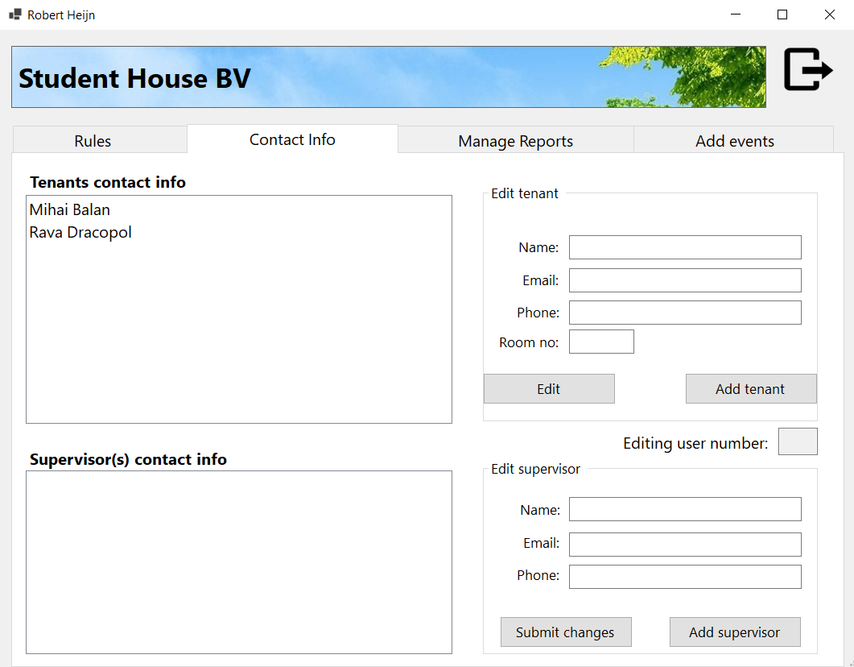

* ***Manage report***

Reports from the tenants are seen here. After they red it and analyze the situation, they can take action and, if necessary, send a warning to a tenant. After they solve an issue, the report can be removed.

* ***Event Schedule***

Supervisors can assign cleaning tasks to the tenants weekly and create events such as “rent is due” or “cleaning team is coming”. These are sorted based on the date when they will happen.

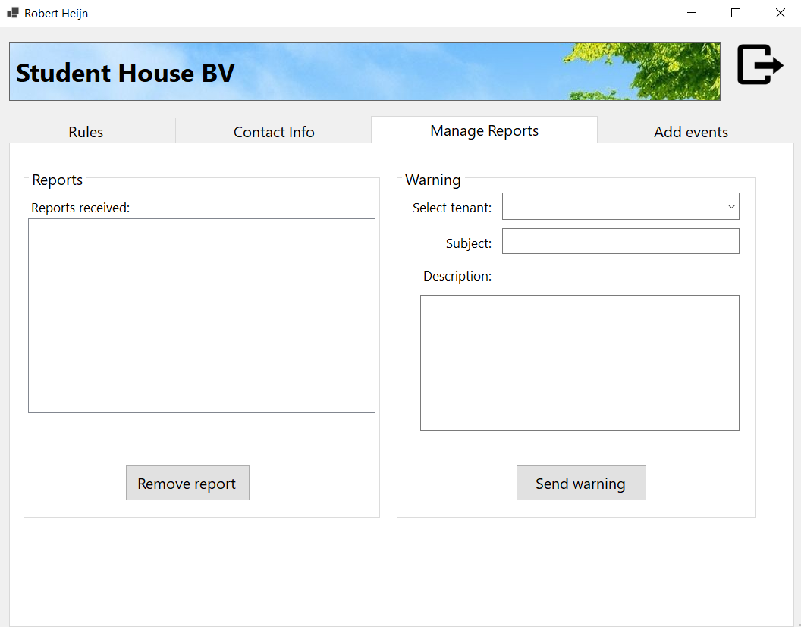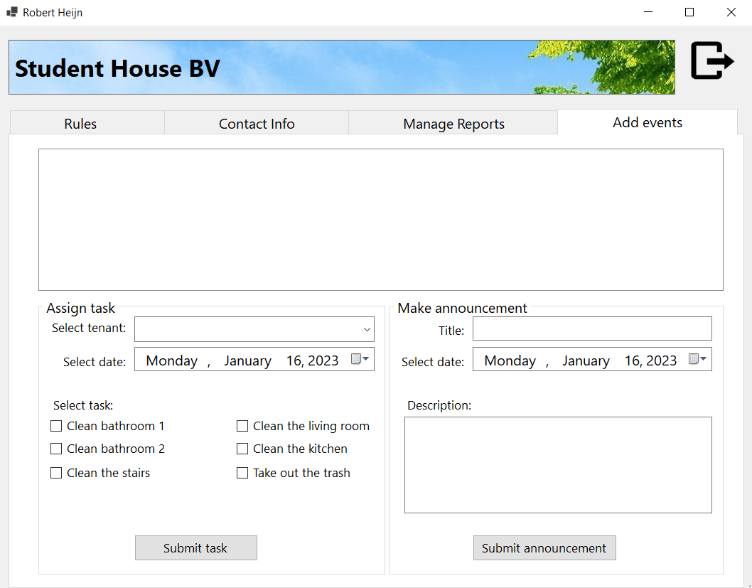

# Process

* First, we defined the problems (the missing system, which provides better communication between the agency and the tenants) of the current case as a team.
* We all came up with some solutions and voted, defined the pros and cons of every solution and decided on what are we going to work on.
* The project plan was created (we had to split the project plan into small parts and assign them to each person in the group, for example Diana did the introduction and problem definition, Denitsa – the flow chart with expectations and planning, Aleksander – risk assessment and Antonio did the MOSCOW chart).
* We made a design for the application in Figma and implemented it into Windows Forms in Visual Studio. We managed to do a login and register form, one for the student and one for the supervisor. The design is the same as in the prototype, we had some discussions about it, but at the end we finalized a great UI/UX design we were proud of.
* We split the work within the group members and made a Gantt Chart of processes and deadlines.
* We built the backend of the application and implement the features needed.

# Communication methods

* **Trello** - We assign tasks for each member in Trello and we decide how long it takes to complete said tasks. We expect that each member will do their work in the designated timeframe and we expect professionalism and hard-work in order to finish the best version of our project on time.
* **What’s app** – We send here our work and we ask for feedback. We send any answers and ideas we have. We announce when we are late or if anything unplanned happens so that we know how to adapt to each situation.
* **GitLab** – It’s the workspace we’ll use in order to send the work to different devices and work on the same code. This way, we can efficiently add new functions to the same program and see which part was done by which member. It will help us coordinate and figure out what parts are missing and improve the final product.
* **Discord** – When we want to implement things together and properly discuss about the project, we use discord, because as it’s the easiest way to share your screen, send materials and ask for feedback.
* **Gantt Chart** – We analyzed the timeline and created a deadline for every task we had so we knew if we are falling behind the schedule or things take longer than expected. We also considered everyone’s plans and created a schedule that fitted us all.

# Conclusions

* After researching the situation in multiple student houses, we found out more problems than we thought so we added more customization to the events and schedule.
* The application can solve up to 80% of the problems in a student house, but if some people are inherently mean, then only the penalties given by the supervisors can solve something.
* It was challenging at first to make a plan for almost two months, not knowing how difficult things are going to be and how long they would take, because we didn’t have the knowledge necessary at the beginning. The first round of planning didn’t really reflected the reality so we needed to change it continuously and update it every time.

# Advice and improvements

* We should have done the UML earlier in order to decide on the structure, because we had to change it multiple times based on the feedback we received. If we had it from the beginning, we could have asked for feedback earlier and start implementing the solution faster.
* We wrongfully estimated the time completion of the task so it was difficult to meet the deadlines.
* We could always improve our communication and decrease the procrastination level.